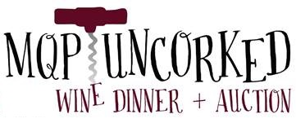
Dear ,

Mary, Queen of Peace Catholic Church has been a vital member of the Sammamish Community for over twenty-five years. Our parish has nearly 2000 families that live and work on the Eastside that are eager to support area businesses.

“MQP Uncorked 2017” was a tremendous success that included raising $25,000 for our local St. Vincent de Paul organization and additional funds to support our many parish programs. Auction proceeds facilitate our ability to continue our mission of “serving others in our local community through stewardship, education, and service.”

We invite you to showcase your business at “MQP Uncorked 2018” scheduled for Saturday, October 13th, 2018 with a donation of a stay at the Salish. Here’s how you can help:
- Contribute an item(s) or service(s) and be acknowledged in our auction catalog and our parish bulletin in the weeks prior to the auction. Please note that any gift certificate with an expiration date should be valid for one year from the date of the auction, through October 13, 2019.
- Become an event sponsor with cash or in-kind donation to help us defray the costs to host the auction. Your company name will be listed in the auction catalog and you will receive recognition at the auction event.
Your name will be included on the item display at the event, in the catalog that will be distributed to all guests in attendance at the auction, and in our weekly bulletin in the weeks leading up to the auction. We also feature our sponsors along with a variety of auction items and donors in all-church displays and our parish website.
Please complete the enclosed auction procurement form and return it by mail or fax at your earliest convenience, before date??? in order to be included in our catalog. Please call the parish office at 425-391-1178 ext. 111 or email paa@mqp.org with any questions.
On behalf of our parish community, thank you for your generosity. We are very grateful for your support.

